**Technology Research**

**Background**

There are many current forms of technology that make up the Gig Economy sphere and the financial apps that support it. The technologies that support this environment are heavily digital based and focus on connecting the two parties involved, namely the gig workers and the customers. Within each company in the Gig Economy space, there exists a typical framework of technology that is utilized to match workers and customers. These technologies directly support the interfaces that the gig workers interact with through their work devices, usually smartphones and tablets. The chart below displays a summary of other functions that happen on the backend to power Uber’s application.[1] Among the more important features that are common to all Gig Economy companies include geolocation, matching algorithms, and dynamic pricing models. It is of note that Uber is being used as an example because it occupies a majority of the gig worker market share in terms of daily users.

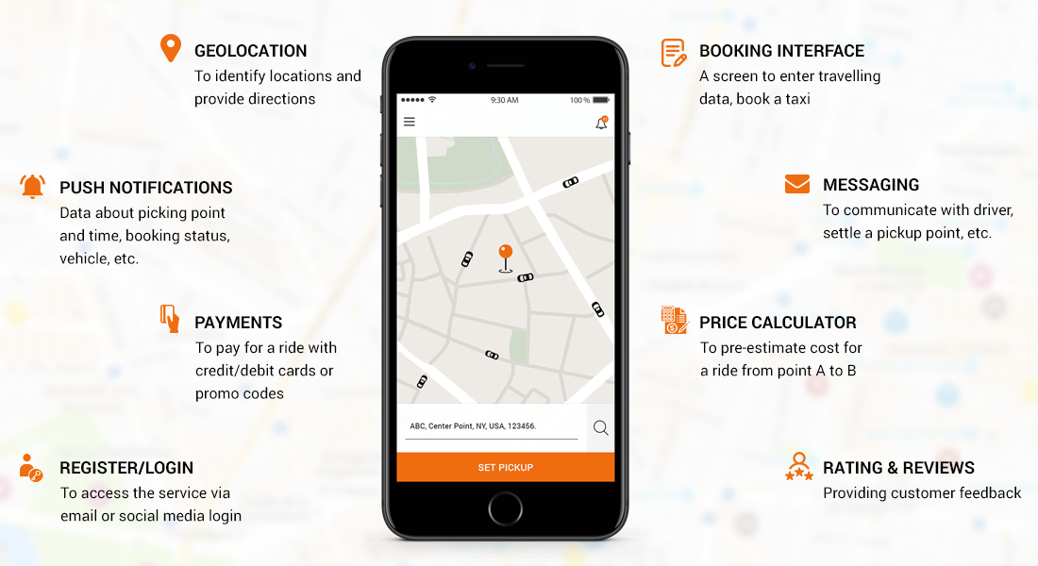

**Geolocation**

One of the most important technology features that applications in the gig economy use is geolocation. This technology allows for the mapping of providers and customers based on inter relational distance. As an important point of gig worker functionality lies in optimized matching and service, minimizing travel distance between matches is a key advantage of company offerings. Uber utilizes Apple’s Core Location framework as well as Google’s Location API and Google Maps’ API to develop their location functionality.[2]

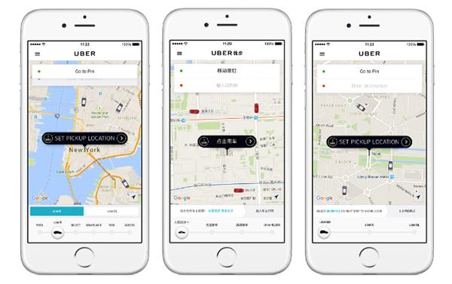

**Matching**

The operations within the gig economy rely heavily on the matching algorithms that each company develops. These algorithms range from automated matching to manual matching and drive the value proposition and differentiation of many of these companies. Uber utilizes a batch matching algorithm that aggregates user requests to process in batches, resulting in lower overall wait times for groups as a whole. Lyft utilizes what they call Route Swapping and Matching Exchange that operates on similar principles, by waiting 30 second intervals before matching to provide more efficient pickups.[3] Companies like TaskRabbit allow customers to manually match in order to select custom services based on quality and price point.

**Pricing**

The Pricing technologies that these companies implement allow for the gig workers to have streamlined, unabated access to their funds. One of the main benefits of gig working is the ability to cash out money earned immediately. To facilitate this, companies use a variety of tools to establish a pipeline between their payout services to user financial institutions. These include the ability to link checking accounts, utilizing PayPal credit card image capture, and integrating tools such as BrainTree, a PayPal service that facilitates mobile payment structure.[4]

1. <https://www.bacancytechnology.com/blog/technology-stack-behind-the-grandeur-success-of-uber>
2. <https://eng.uber.com/tech-stack-part-one/>
3. <https://eng.lyft.com/matchmaking-in-lyft-line-part-3-d8f9497c0e51>
4. <https://stackshare.io/taskrabbit/taskrabbit>